Challenges in Deregulating Electricity:
Drawing Lessons from the California Experience

Tim Brennan

Professor, Policy Sciences and Economics
University of Maryland, Baltimore County
Senior Fellow, Resources for the Future, Washington, DC
brennan@umbc.edu
National Energy Modeling System/Annual Energy Outlook Conference
Energy Information Administration, U.S. Department of Energy
Crystal City, VA
March 12, 2002

California assessment

Basic explanations for California crisis seem clear

Supply/demand crunch

Bankruptcy when utilities had to buy high, sell low

Political paralysis: Who pays

But are popular lessons the right ones?

“California’s deregulation was a disaster”

“California didn’t deregulate enough”

“Generators ‘gamed’ PX auction”

“Too little real-time metering, not enough incentive to conserve”

“Long-term contracting limited”

“Generators exercised market power”

“Wholesale price-caps a temporary fix”

Fundamental issue:
“But for California’s mistakes, electricity markets work”

Reliability: the crucial challenge

California debacle a distraction from fundamental questions

Is “Markets or not?” fact or ideology

Is electricity on the other side of the line?

What makes electricity unique—three combined factors

Crucial to the economy

2-3% of US GDP an understatement

The “e” in e-commerce

Infrastructure industry—economic development tool (US rural electrification, LDCs)

Vulnerability from load imbalances

Keeping supply and demand always in line

Prohibitive storage costs

Inter-relatedness

Perhaps forgotten in the rush to open markets

One company’s load imbalance can bring down the system

Varying degrees of central control

“California wasn’t always a disaster”
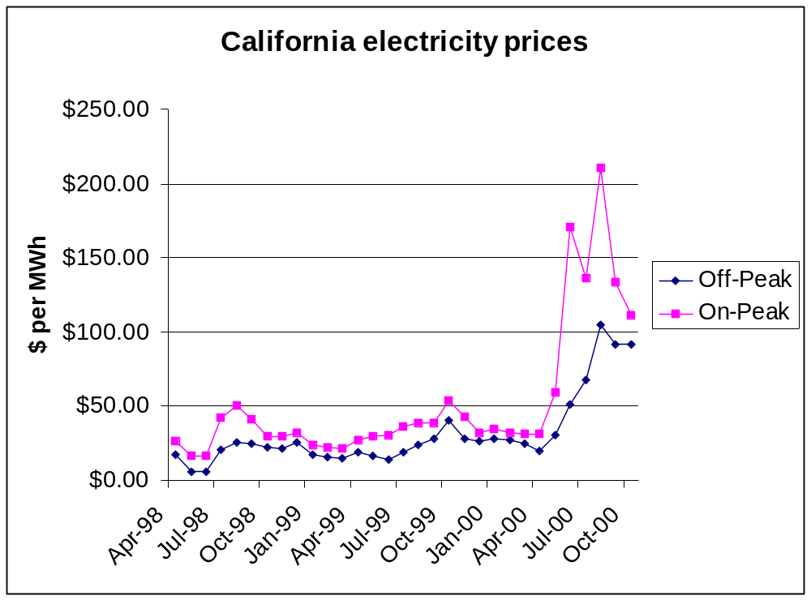

“California didn’t deregulate enough”

In some ways, regulation a clear problem

Retail rates held down while wholesale rates rose

PG&E bankrupt; others close, getting bail-outs

But limits to deregulation

Local distribution physical natural monopoly

Transmission – loop flow externalities

Only solution: distributed generation

Need to separate regulated control from unregulated service ownership

Cross-subsidization, discrimination

US v AT&T precedent

ISO, “TransCo,” RTO, Independent Transmission Administrator:
Separate transmission from generation

Separate retailing from distribution?

“Generators ‘gamed’ PX auction”

Markets worked through May, 2000, over 2 years

Auction could hurt when supplies tight

All get market clearing price

Bid in supply curves, offer quantity at high price?

Small loss, big upside

Car dealership contrast

Problems

Free-riding

No minimum equilibrium quantity

Mitigation strategies

Pay only bid price – leads to high strategic bidding

Minimum quantity bids, raise losses from high bids not taken

Why have a central auction?

“Too little real-time metering”

Important incentive to conserve

Conventional metering allows only average pricing

No incentive to reduce or shift use at peaks

Very high price differentials (10X or more)

Is this a policy issue? What is the externality?

Incentive for those who buy high, sell low to pay consumers to install meters

Do we mandate real-time pricing in restaurants?

Benefits of real-time pricing finite

Possible rationales

Obligation to serve, no externality

Possible externality with inefficient rationing (blackouts)
Also, in electricity, blackouts not localized

Third party benefits from reducing the queue

Market power mitigation?

“Long-term contracting would be a big help”

Huge effect in hindsight, but going forward?

Like “should’ve bought fire insurance” after house burns

But does insurance construct more houses?

Did lack of contracts discourage supply in 2000? Probably not

Past price effect misleading; contract price equals expected spot price (less willingness to pay to avoid risk)

More entry would depress price off-peak; all capital recovered on-peak (resort hotels)

Problems with long-term contracts

Moral hazard: Too much consumption at low price

Distributor-generator linkages cross regulated-unregulated boundary

“Generators exercised market power”

Crying wolf: Accusations when prices only 20%, not 400+% above prevailing levels

Collusion possible, but unlikely and illegal (210 defendants)

Unilateral

Dominant firm, oligopoly models predict high price-cost margins with small market shares

Legal, at least under US antitrust law

Empirical price-cost margin studies confirm, but problems

Price one gets, not price one sets: buyer bankruptcy risk

Price does not equal marginal (average variable) cost at peak periods under competition

Resort hotels, again

“Wholesale price caps an effective, temporary response”

Efficiency effects

With competition, caps would reduce supply, lead to blackouts, rationing

With monopoly, gaming, caps would increase supply

Distributional issues huge motivator

On peak huge rent transfer with deregulation

Peak capital recovery perhaps 100 times baseload per hour

Can politicians wait for new entry to depress off-peak prices down to zero profit overall level?

Do equities outweigh efficiencies, if price “high enough” to induce entry?

Could long-term contract flexibility accelerate benefits from future efficiencies?

Implementation difficulties

Highest average variable cost not appropriate standard; FERC error

Are they “temporary,” if invoked anytime peak demand approaches (predictable) capacity constraint?

“But for California mistakes, deregulation really works”

California “troubles” distract attention from core problem

Market power, environmental problems we know how to solve

Antitrust, regulation, taxes and permits

CA mistakes give false sense of security

“Importance,” “vulnerability,” inter-relatedness” => Reliability

Unique combination of electricity attributes

Outages largely local, but could they become regional or national?

Industry-wide response may be required

My expected “killer” wasn’t price, but finger-pointing when the lines went down

Can we make reliability compatible with markets?

Competition vs. cooperation, regulation, or planning – THE big issue

Will competitors cooperate? Should they cooperate?

Grid responsibility vs. generator liability

How much centralized control do we need?

Jurisdictional issues

US: Interstate reliability, super-Regional Transmission Operators

Canada: The role of provincial regulatory authorities

International governance

Canada and the US: Merging FERC and the National Energy Board?

EU, Asia issues

Have markets met their match?

Is electricity the exception to our rules?

Is advocacy based on facts, theory, or ideology?

Might market advocacy be more effective if exceptions conceded?

